**DAILY ONLINE ACTIVITIES SUMMARY**

|  |  |  |  |  |  |  |  |
| --- | --- | --- | --- | --- | --- | --- | --- |
| **Date:** | **25/05/2020** | | | | **Name:** | **Albin Francis** | |
| **Sem & Sec** | **8 A** | | | | **USN:** | **4AL16CS008** | |
| Online Test Summary | | | | | | | |
| **Subject** | | **------** | | | | | |
| **Max. Marks** | | **------** | | **Score** | | **------** | |
| Certification Course Summary | | | | | | | |
| **Course** | **Getting Started To Hadoop** | | | | | | |
| **Certificate Provider** | | | **GreatLearning** | **Duration** | | | **5.5hr** |
| Coding Challenges | | | | | | | |
| **Problem Statement:**  **1)Write a recursive function to calculate the sum of numbers from 0 to 10** | | | | | | | |
| **Status: Solved** | | | | | | | |
| **Uploaded the report in Github** | | | | **Yes** | | | |
| **If yes Repository name** | | | | **albinfrancis008** | | | |
| **Uploaded the report in slack** | | | | **Yes** | | | |

Online Test Details: -

Certification Course Details:

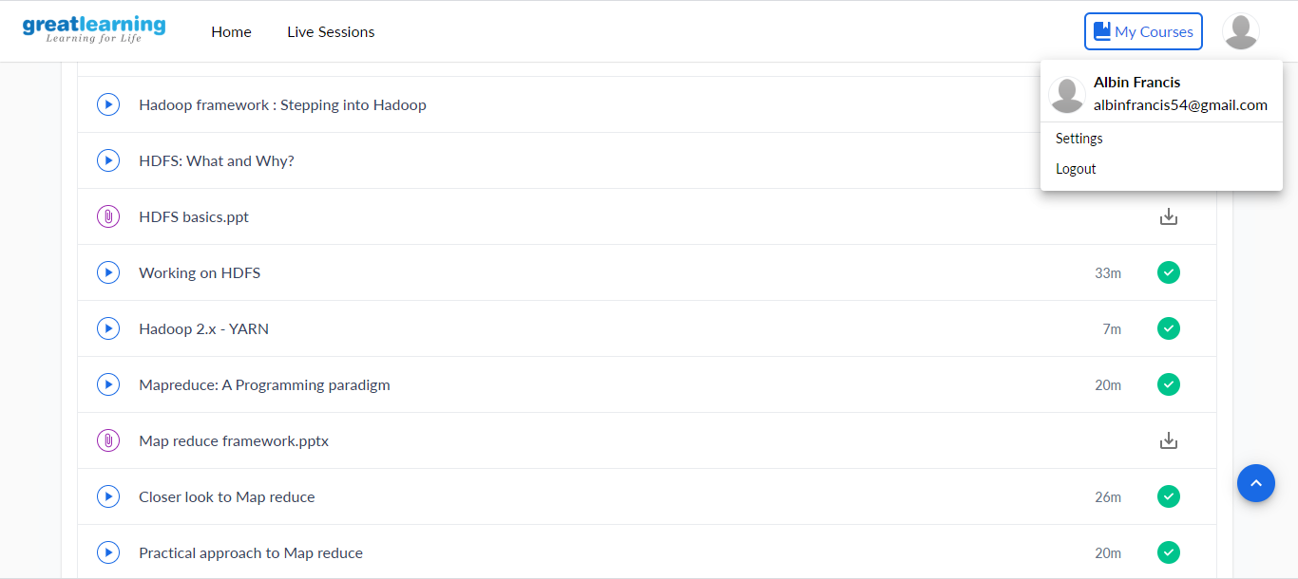

PRACTICAL APPROACH TO MAP REDUCE:-

* Setting up of Vmvare in linux for hadoop
* Using of LXTERMINAL
* Start using unix file system and hdfs sile system commands.
* Creating of a text file to execute
* Using of Eclipse
* And having files for driver,mapper and reducer
* Using some of the predefined hadoop mapreduce methods we will

Be getting the final output

Coding Challenges Details:

**1)Write a recursive function to calculate the sum of numbers from 0 to 10**

def calculateSum(num): if num:

return num + calculateSum(num-1) else:

return 0

res = calculateSum(10) print(res)